
CIO, Charity registration No: 1197368

Affiliated to the Swim England East Region
Presents:

HATFIELD Autumn Regional Qualifier October 2025
A LEVEL 3 Licensed meet No: 3ER251265
Under Swim England Laws & Technical Rules of Swimming
The Hertfordshire Sports Village, Hatfield, Hertfordshire

Saturday 4th & Sunday 5th October 2025
(Closing date 3rd September 2025 @10pm)
The Meet
- The Meet Promoters are VALERIE BOREL and FEDERICA TITON (promoter@hatfieldswimmingclub.org ) on behalf of the Hatfield Swimming Club. The event will be held at The Hertfordshire Sports Village, Hatfield, Hertfordshire.
- The competition is to be held under Swim England laws and technical rules of swimming.
- The competition is licensed by Swim England as a LEVEL 3 meet. Licence no. 3ER251265.
- The pool length is 25m and there are 8 lanes with anti-turbulence lane ropes. Omega AOE will be used at the meet. A secondary strobe for the starting equipment is available. The depth of the pool is 1.8 metres across the pool.
- Entrants must be Swim England Registered at Category Club Compete and have a Swim England number and belong to an affiliated club or WASA and SASA equivalent and National Associations of World Aquatics.
- Upper qualifying times are in operation for this meet as provided in the accompanying schedule. Converted LC times won’t be accepted. There are no lower limit times. Swimmers must have a time recorded on Swim England rankings since 1st January 2024. Times faster than the upper limits, achieved inside the regional qualifying window and no times entries will not be accepted.
- Clubs entering more than 5 swimmers must do so electronically by using SportSystem Entry Manager or other formats supplied by the promoter.
- Entries of 1 swimmer only can be accepted by the supplied files or on the manual entry form along with a summary sheet. A manual entry will be subject to an administration fee of £2.
- The swimmers in possession of a Swim England Certificate of Swimming Disability or the swimmers whose membership details record a disability Sport Class are welcome to enter the competition. An entry time must be provided.
- The promoter reserves the right to accept entire entries from visiting overseas clubs due to the need to advance book travel arrangements. Entry times must be evidenced from a suitable ranking system and fall within the qualifying times of the meet.

- Entry fees will be £9 per event (this includes the Swim England levy) for all 50s, 100s and 200s; £11 for 400s.
- Entry forms, SportSystems files, and entry payments must be received by the promoters on or before the specified closing date of 3rd September 2025 and be fully and correctly completed. The Promoter reserves the right to re-open the Meet for entries (and/or to offer time trials) after the closing date if there is capacity and entirely at the Promoter’s discretion. Swimmers offered late entries/time trials will be subjected to an entry fee of £10 per event and must have an entry time to ensure that they fall within the qualifying times.
- Entries which do not follow the above procedures may be rejected.
- Entries will be restricted to ensure the meet runs to time and will be accepted on a ‘first come first served’ basis, but with consideration to balancing out the numbers in each year age category. The entry fees should be paid to Hatfield Swim Club CIO, sort code: 30-96-26, account number: 78752968, when the entries file is sent.
- If the event is oversubscribed the promoter reserves the right to return entries. Refunds will be made by a single payment to the club concerned. The promoter’s decision is final.
The Events
- OVER THE TOP starts will be used in the heats if required by the referee.
- ALL BUT HEAT DECLARED RACES will be SPEARHEADED with fastest 3 heats CYCLICALLY seeded.
- 200m and 400m events are heat timed finals. All other events are heat times, and final times except for events described in sections 18-20.
- 50Free finals will be held for Juniors at the end of finals in session1 before the 50Free Skins.
- 50Free Skins’ events will be held at the end of finals in session1 for the open age group category. The skins will be eight fastest swimmers (open) from 50m freestyle heats. Times achieved during 1st round of the 50Free skins are eligible for Rankings but not the times from subsequent rounds.
- ‘Medley skins’ events will be held at the end of finals in session3 for 200IM. The skins will be eight fastest swimmers (open) from 200IM heats. A random draw will be done for strokes. Times achieved during this skins’ event are not eligible for Rankings.
- Age groups are: 10,11,12,13,14,15, 16/over years.
- Ages are as on 5th October 2025.
- Awards will be given to the first 3 in each year group (above) in each event (heat and finals).
- The fastest 8 swimmers in combined age groups 14/Under will be selected to swim Junior Finals (other than 200 and 400m events) and the fastest 8 swimmers in combined age groups 15/Over will be selected to swim Senior Finals (other than 200 and 400m events). A minimum of 4 and a maximum of the 10 fastest swimmers will be called for each final, in the latter case the slowest two will be reserves.
Pre-Meet Info
Advertised on the web for all competitors to see – www.hatfieldswimmingclub.org
- Session timings may be adjusted depending on the number of entries received and accepted. Any changes will be posted on the Hatfield SC website www.hatfieldswimmingclub.org
- A list of accepted entries & rejections will be posted on the web as confirmation.
- Swimmers must withdraw from events heats that they no longer wish to swim. Withdrawal slips will be available from the recorders desk on the day or may be e-mailed in advance to entries secretary (entries@hatfieldswimmingclub.org ) with swimmers information (name, Club, SE membership number, event number).
On the day all withdrawals must be made 50 minutes prior to the start of the first event in each session, coinciding with the start of warm-up. Swimmers failing to attend the start of a heat without withdrawing will incur a £5 penalty, which will be deducted from any refunds or invoiced to the club. Refunds are not available for withdrawals, other than for medical reasons.
- Swimmers who do not wish to swim finals must withdraw within 5min of the swim down/warm-up for finals. Withdrawal sheets will be displayed to clubs at the door of the control room next to announcer’s desk.

Passes & Payments
- Coaches’ and Team Managers’ passes will be available at a cost of £35 for the weekend for coaches/TM passes (including access to catering room, poolside drinks/sweets/fruits, heat sheets), or £25 for Sunday or £12.50 for Sat only. We will also have the option of £15 weekend (or £7 for 1 session) with poolside drinks/fruit/sweets only (no access to catering room).
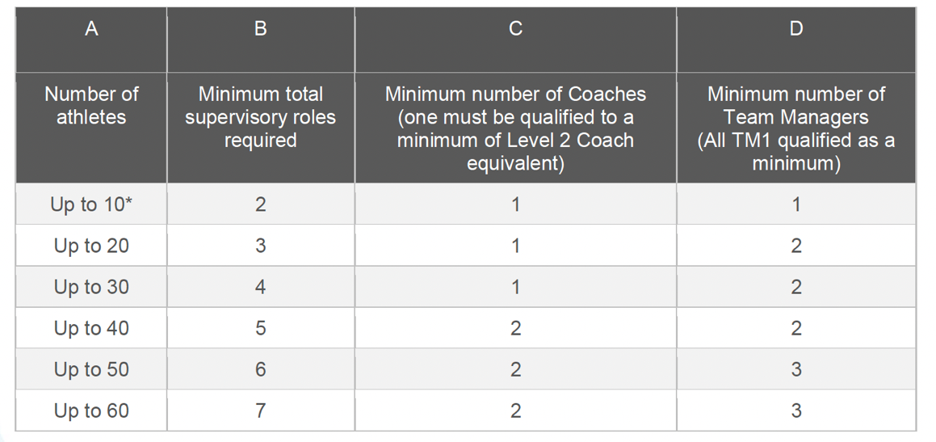
- Participating clubs are required to ensure compliance with Swim England’s Team Manager, Coach and Chaperone Policy 2023 that came into effect on 1st September 2023. Details can be found HERE
These ratios are based on the team being in a single supervision area. Clubs should note these are the minimum supervision standards. It is the responsibility of the entered Club to ensure that the coaches and team managers they have on poolside are fully compliant with Wavepower 2024 (Swim England Safeguarding policy).
- Passes can only be obtained by completing the meet summary form with named persons/coaches and submitting it to the Promoter. Passes must be displayed at all times. Passes entitle the coach to refreshments/food between sessions, access to pool side, plus copies of all relevant meet information on the day.
- Clubs should make their entries collectively and send payment via electronic banking (details enclosed on Summary Sheet). Refunds will only be payable to the entered club.
- Only swimmers, team managers, coaches, officials and Hatfield SC volunteers will be allowed on poolside. Spectators are welcome in the viewing gallery and there will be a charge of £5 per session.
- All swimmers should be supervised by their coaches/team managers during warm up and whilst on poolside.
General
- By submitting an entry form or SportSystems entry, Clubs, Competitor’s and Coaches are agreeing to be bound by these rules.
- Any matter not covered by these conditions will be determined by the Promoter and Referee, subject to Swim England Laws, Regulations and the Swim England Technical Rules of Racing.
Data Protection
- The Data Protection Act 2018 requires us to provide you with certain information and to obtain your consent before processing data about you. Processing includes: obtaining, recording, holding, disclosing, destruction or retaining information. We require certain personal data for the purposes of making entries to the competition, managing the meet and the submission of results to Rankings. The information provided by you will be processed in accordance with the Data Protection Act 2018. Consent to process such personal data is deemed to have been given by the submission of the entry. Where the personal data of competitors, officials and coaches/team managers has been passed to us by a third party such as a club rather than by the individuals themselves, we rely on the third party to ensure that consent has been obtained.
Mobile phone and device use/ Photography
- In accordance with Swim England Safeguarding policy (Wavepower 2024) any parents or carers of swimmer under the age of 18 who wish to take photographic or video images are requested to focus on their own swimmer as much as reasonably possible and to avoid including other swimmers in those images, particularly if those images are being shared with family and friends through social media platforms.
- Participants and spectators are requested to follow the Swim England guidelines for mobile phone or device use, photography and use of photographs on social media. The Swim England Safeguarding Policy, Wavepower 2024 provides guidance on the use of social networking and, guidance on mobile phones and devices. https://www.swimming.org/swimengland/wavepower-child-safeguarding-for-clubs/. Both sets of guidance apply if social media platforms are being used to share images or recordings either after the meet or during the event.
Note that mobile phone or device use in changing rooms is absolutely forbidden by Wavepower 2024, the club and the swimming pool management.
Should you have any concerns about photography or filming at this event then please bring them to the attention of Meet Promoter.
All participants must observe the safety precautions in operation at Hertfordshire Sports Village. Neither the Promoter nor Hatfield Swimming Club will be responsible for any loss or damage occurring during this meet.

